Heros of Pymoli Analysis Review

Jake Hatcher

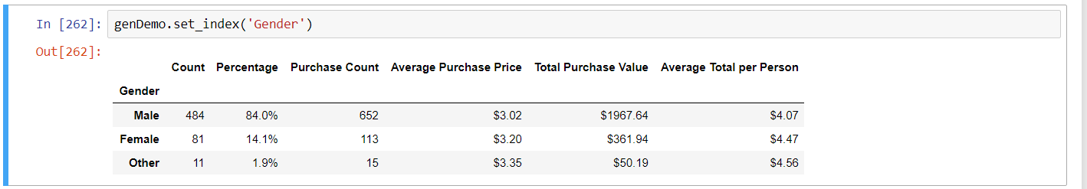

Our main demographic of players if you go by gender is male, however if you look at average amount invested in the game there is little difference in investment in the game by gender and players who identified as something other than male actually have a slightly higher investment in the game.

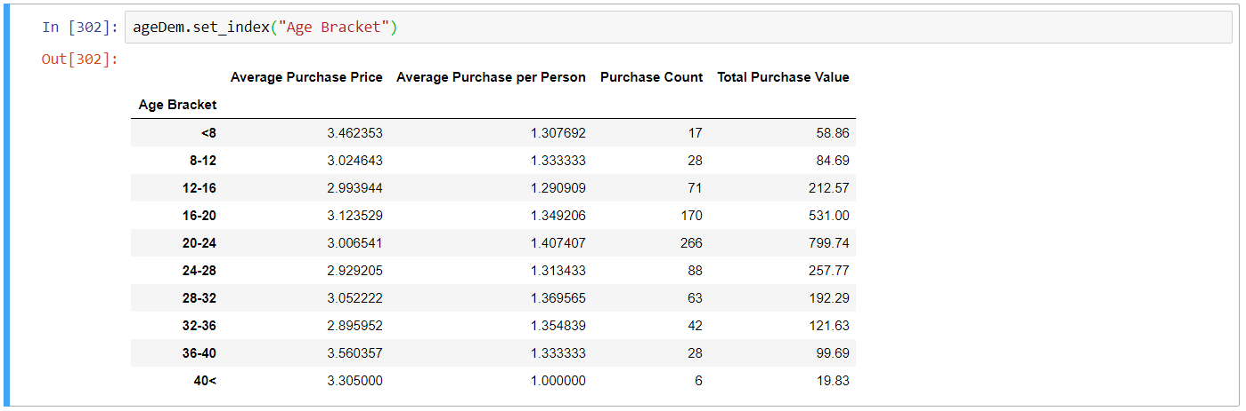

Our largest group of invested players lie within 16 – 24 years of age. To hit the most of our players interest it is highly recommended to focus on the teen to young adult demographic. On average about 1 in 3 players who invest in the game will invest again.

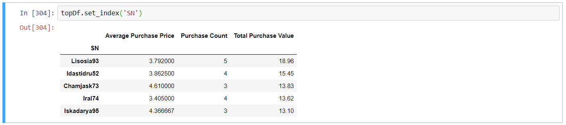

Top players have bought around 4 items. The ones who bought more bought slightly cheaper items on average

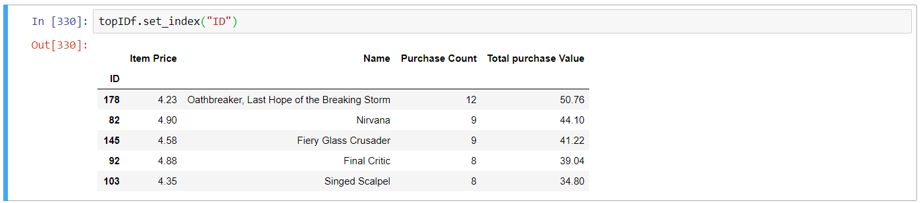

Interesting to note that for the most part the players who invested the most into the game payed on average less per item than the top selling item prices. This gives evidence that players who purchase less frequently are more likely to spend more on an individual item but less over the course of their gaming time. While players who invest more into the game overall will invest in smaller chunks.